EXPT NO:03 | EDA-DATA INSPECTION AND ANALYSIS

AIM:
To inspect and analyze the Student Performance Factors dataset using Exploratory Data Analysis (EDA) to understand the data structure, identify missing values and duplicate records, detect outliers, analyze important student attributes, and discover relationships between different factors affecting student examination performance.

PROCEDURE:
- Import Pandas, NumPy, Matplotlib, and Seaborn libraries.
- Load the Student Performance Factors dataset using Pandas.
- Display the first and last records using head() and tail().
- Check the number of rows and columns using shape.
- Display column names and data types using info().
- Check missing values using isnull().sum().
- Generate statistical summaries using describe().
- Check and identify duplicate records.
- Analyze important student attributes such as study hours, attendance, previous scores, gender, parental education level, and exam score.
- Create suitable graphs such as histograms, bar charts, and scatter plots.
- Generate a correlation heatmap to identify relationships between numerical variables.
- Detect numerical outliers using the IQR method and visualize them using box plots.
- Interpret the findings and identify important patterns in the Student Performance Factors dataset.

CODE:
import pandas as pd
import numpy as np
import matplotlib.pyplot as plt
import seaborn as sns
# 1. Load Dataset
df = pd.read_csv("StudentPerformanceFactors.csv")

print("Original Dataset:")
print(df.head())

# 2. Display Last Records
print("\nLast 5 Records:")
print(df.tail())
# 3. Dataset Shape
print("\nDataset Shape:")
print(df.shape)

# 4. Dataset Information
print("\nDataset Information:")
df.info()

# 5. Column Names
print("\nColumn Names:")
print(df.columns.tolist())

# 6. Missing Values
print("\nMissing Values in Each Column:")
print(df.isnull().sum())

# 7. Statistical Summary
print("\nStatistical Summary:")
print(df.describe())

# 8. Duplicate Records
print("\nNumber of Duplicate Rows:")
print(df.duplicated().sum())

# Remove duplicate records
df = df.drop_duplicates()
print("\nDuplicate Rows After Removing:")
print(df.duplicated().sum())

# 9. Important Attribute Analysis
print("\nAverage Exam Score:")
print(df["Exam_Score"].mean())

print("\nAverage Hours Studied:")
print(df["Hours_Studied"].mean())

print("\nAverage Attendance:")
print(df["Attendance"].mean())

print("\nAverage Previous Score:")
print(df["Previous_Scores"].mean())

# 10. Gender Analysis
print("\nAverage Exam Score by Gender:")
print(df.groupby("Gender")["Exam_Score"].mean())

# 11. Parental Education Analysis
print("\nAverage Exam Score by Parental Education Level:")
print(df.groupby("Parental_Education_Level")["Exam_Score"].mean())

# 12. Histogram - Exam Score
plt.figure(figsize=(7, 5))
sns.histplot(df["Exam_Score"], bins=20, kde=True)
plt.title("Distribution of Exam Scores")

plt.xlabel("Exam Score")
plt.ylabel("Number of Students")
plt.show()

# 13. Bar Chart - Gender
plt.figure(figsize=(7, 5))
sns.barplot(
data=df,
x="Gender",
y="Exam_Score",
estimator="mean"
)

plt.title("Average Exam Score by Gender")
plt.xlabel("Gender")
plt.ylabel("Average Exam Score")
plt.show()

# 14. Scatter Plot
# Hours Studied vs Exam Score
plt.figure(figsize=(7, 5))
sns.scatterplot(
data=df,
x="Hours_Studied",
y="Exam_Score"
)
plt.title("Hours Studied vs Exam Score")
plt.xlabel("Hours Studied")
plt.ylabel("Exam Score")
plt.show()

# 15. Scatter Plot
# Attendance vs Exam Score
plt.figure(figsize=(7, 5))
sns.scatterplot(
data=df,
x="Attendance",
y="Exam_Score"
)

plt.title("Attendance vs Exam Score")
plt.xlabel("Attendance")
plt.ylabel("Exam Score")
plt.show()

# 16. Correlation Heatmap
numeric_df = df.select_dtypes(include=np.number)

plt.figure(figsize=(10, 7))
sns.heatmap(
numeric_df.corr(),
annot=True,
cmap="coolwarm",
fmt=".2f"
)

plt.title("Correlation Heatmap of Student Performance Factors")
plt.show()
# 17. Outlier Detection using IQR
print("\nOutlier Detection:")
numeric_columns = df.select_dtypes(include=np.number).columns
outlier_result = {}
for col in numeric_columns:
Q1 = df[col].quantile(0.25)
Q3 = df[col].quantile(0.75)
IQR = Q3 - Q1
lower_bound = Q1 - (1.5 * IQR)
upper_bound = Q3 + (1.5 * IQR)
outliers = df[
(df[col] < lower_bound) |
(df[col] > upper_bound)
]
outlier_result[col] = len(outliers)

print(outlier_result)
# 18. Box Plots for Outlier Visualization
for col in numeric_columns:
plt.figure(figsize=(7, 4))
sns.boxplot(x=df[col])
plt.title("Outlier Detection - " + col)
plt.xlabel(col)
plt.show()
# 19. Final Dataset Information
print("\nFinal Dataset Shape:")
print(df.shape)
print("\nAnalysis Completed Successfully!")

OUTPUT:
Original Dataset:
Hours_Studied Attendance Parental_Involvement Access_to_Resources
0 23 84 Low High
1 19 64 Low Medium
2 24 98 Medium Medium
3 29 89 Low Medium
4 19 92 Medium Medium

Extracurricular_Activities Sleep_Hours Previous_Scores Motivation_Level
0 No 7 73 Low
1 No 8 59 Low
2 Yes 7 91 Medium
3 Yes 8 98 Medium
4 Yes 6 65 Medium

Internet_Access Tutoring_Sessions Family_Income Teacher_Quality
0 Yes 0 Low Medium
1 Yes 2 Medium Medium
2 Yes 2 Medium Medium
3 Yes 1 Medium Medium
4 Yes 3 Medium High

School_Type Peer_Influence Physical_Activity Learning_Disabilities
0 Public Positive 3 No
1 Public Negative 4 No
2 Public Neutral 4 No
3 Public Negative 4 No
4 Public Neutral 4 No

Parental_Education_Level Distance_from_Home Gender Exam_Score
0 High School Near Male 67
1 College Moderate Female 61
2 Postgraduate Near Male 74
3 High School Moderate Male 71
4 College Near Female 70

Last 5 Records:
Hours_Studied Attendance Parental_Involvement Access_to_Resources
6602 25 69 High Medium
6603 23 76 High Medium
6604 20 90 Medium Low
6605 10 86 High High
6606 15 67 Medium Low

Extracurricular_Activities Sleep_Hours Previous_Scores
6602 No 7 76
6603 No 8 81
6604 Yes 6 65
6605 Yes 6 91
6606 Yes 9 94

Motivation_Level Internet_Access Tutoring_Sessions Family_Income
6602 Medium Yes 1 High
6603 Medium Yes 3 Low
6604 Low Yes 3 Low
6605 High Yes 2 Low
6606 Medium Yes 0 Medium

Teacher_Quality School_Type Peer_Influence Physical_Activity
6602 Medium Public Positive 2
6603 High Public Positive 2
6604 Medium Public Negative 2
6605 Medium Private Positive 3
6606 Medium Public Positive 4

Learning_Disabilities Parental_Education_Level Distance_from_Home
6602 No High School Near
6603 No High School Near
6604 No Postgraduate Near
6605 No High School Far
6606 No Postgraduate Near

Gender Exam_Score
6602 Female 68
6603 Female 69
6604 Female 68
6605 Female 68
6606 Male 64
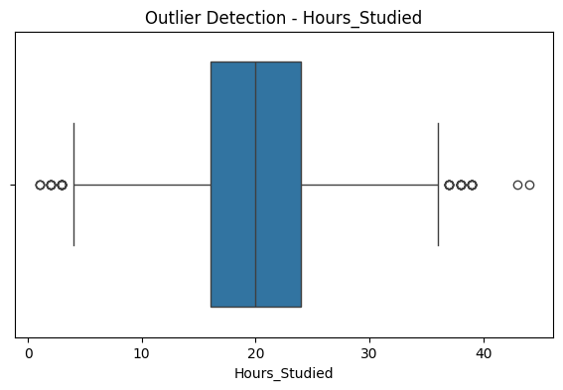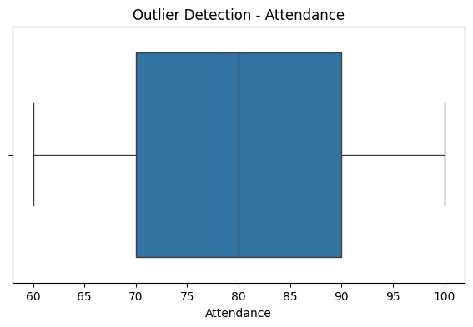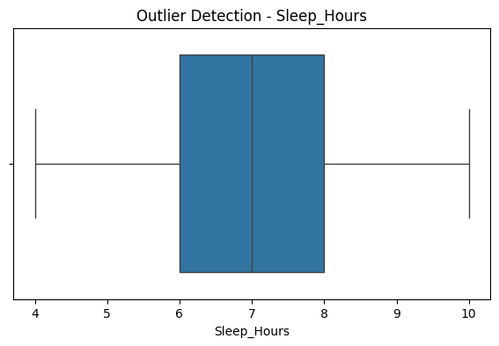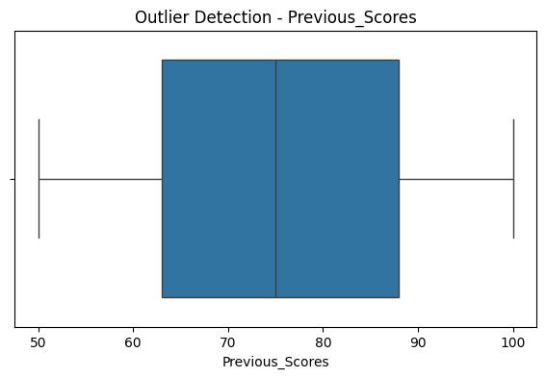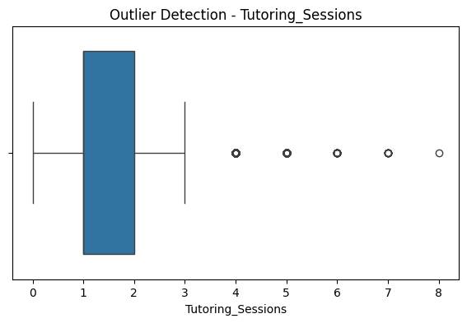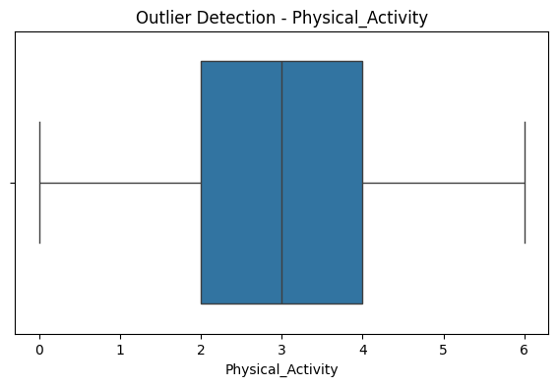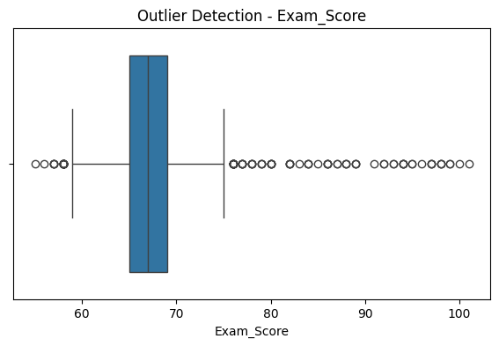

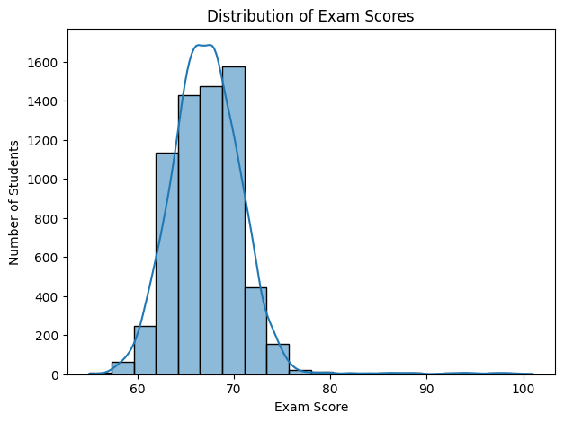

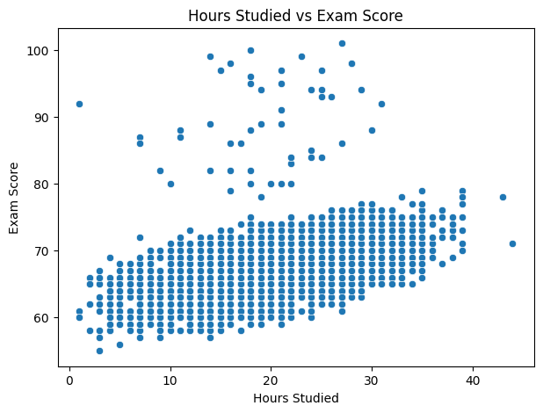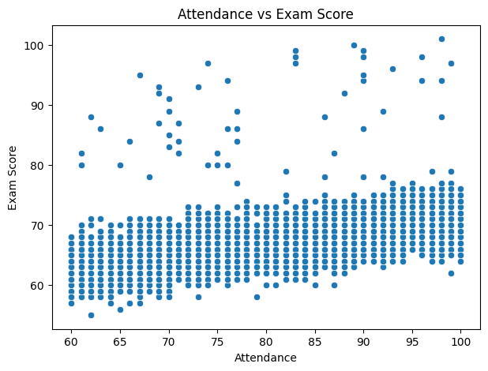

Result:

